Coordinators’ Report
September 7, 2013
Prepared by: Agnieszka Przeszlowska
& Rhianna Williams

This report reviews tasks included in the 4 strategic categories of the Operating Plan adopted Jan. 2013.

Category 1. Organization and Coordination

On Sept. 4, 2013, Emily Galanto bid farewell to Ouray County as she headed back to the East Coast, this time Vermont. Emily spent a year serving the UWP as an OSM/VISTA Volunteer and then working as an interim coordinator during summer 2013. During her tenure with UWP, she had greatly enhanced and expanded UWP’s programs and partnerships, especially outreach and education initiatives. Thank You Emily!

Our current OSM/VISTA Volunteer, Rhianna Williams is already in her 5 month of service with the UWP. She has been busy coordinating various summer outreach events and gearing up for educational programs with the start of the 2013-2014 school year. Most recently, she collaborated with Jerry Roberts and Agnieszka to prepare a grant application to Patagonia for funding for a greenhouse project at Ridgway Secondary School (see Grant Writing section for more details).

After a three month maternity leave, Agnieszka returned to work in mid-August on a part-time basis. Her priorities for the fall months will be to revise and finalize the budget and scope of work for UWP’s mine remediation projects, complete reports for current grants, and update UWP’s financials. She will also facilitate the development of UWP’s Governance Manual and participate in developing the Strategic Plan.

Through the summer months, the new UWP Board of Directors had an opportunity to participate in several UWP’s programs (i.e. river festival, fundraisers, outreach events, stewardship projects) and develop some of UWP’s operating procedures. Scott Williams drafted Financial Policies and Procedures, Scott, Ken, Jerry, Anthony was formed the Finance Committee which met at the end of August 2013 to discuss the 2014 budget, Jerry helped with preparation of a Patagonia grant, and Judi Chamberlin spearheaded an Adopt-a-Park volunteer day at Rollans Park. In October, the Board will select a Development Committee to develop UWP’s Strategic and Operating Plans. Ken has agreed to provide a primer on Strategic Planning and help spearhead the effort.

At the beginning of August we received a notice from IRS, dated Aug. 7, 2013 that the Department has received our application for Federal income tax exemption and that we will be notified within approximately 90 days from date of notice regarding the status of our application.
Category 2. Fundraising and Grant Writing

Fall Fundraiser: As described in earlier reports, Rhianna and Jerry have been planning an invited speaker event with Jon Waterman for Dec. 3, 2013 at the Wright Opera House. The details are coming together but we will need everyone’s help in promoting this community event.

Grants:

Patagonia: At the end of August 2013, Rhianna submitted a grant proposal to Patagonia requesting $11,000 for the construction of a greenhouse at the Ridgway Secondary School. The goal of the Greenhouse Project will be to 1) provide space for a riparian plant nursery where students and UWP can propagate starts for various river restoration projects and 2) provide space and opportunity for teachers to develop ecology and environmental science projects to enhance secondary level science curricula. Funds from this grant will be matched by applying to the Colorado Watershed Restoration Program with Colorado Water Conservation Board and funds or in-kind donations from the Ridgway School District, Mosaic Community Project and EcoAction Partners.

Colorado Watershed Restoration Program (CWRP): Agnieszka and Rhianna will prepare a grant proposal to the CWRP of the Colorado Water Conservation Board to request additional funds (approximately $14,000) for the Greenhouse Project as described above. The deadline for submissions is Sept. 30, 2013.

Mosaic Community Project: At the end of August 2013, Rhianna requested $1,000 from the Mosaic Community Project for greenhouse supplies to support the overall Greenhouse Project. The MCP Board will review the request at the beginning of October.

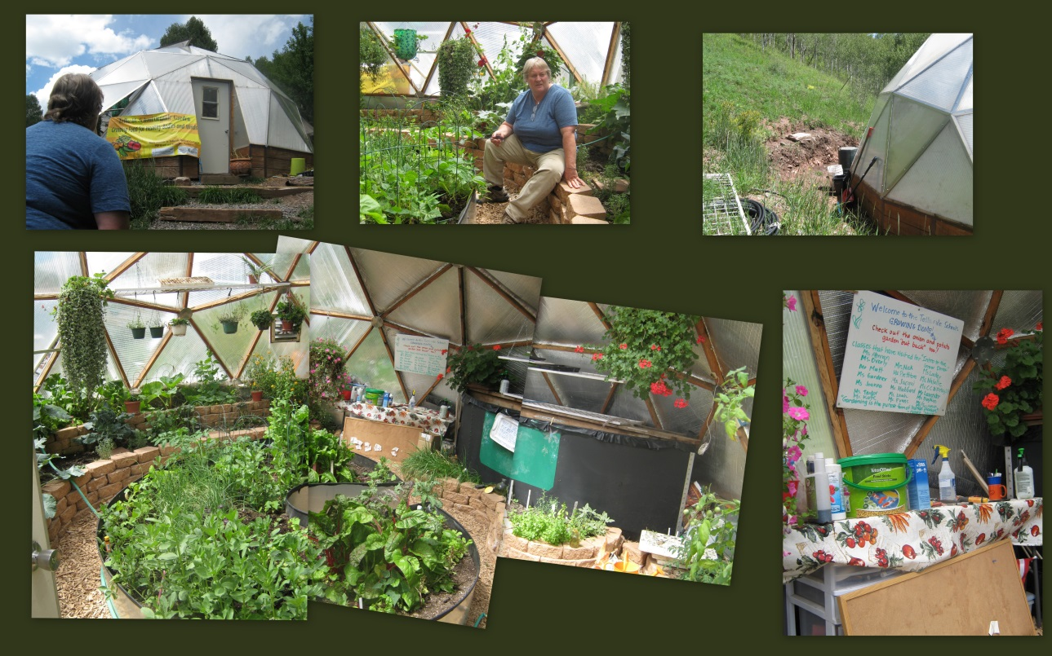
Figure 1. Pictures of 26-foot diameter greenhouse constructed for a school in Telluride, CO.
This is a prototype for which we are seeking grant funds.

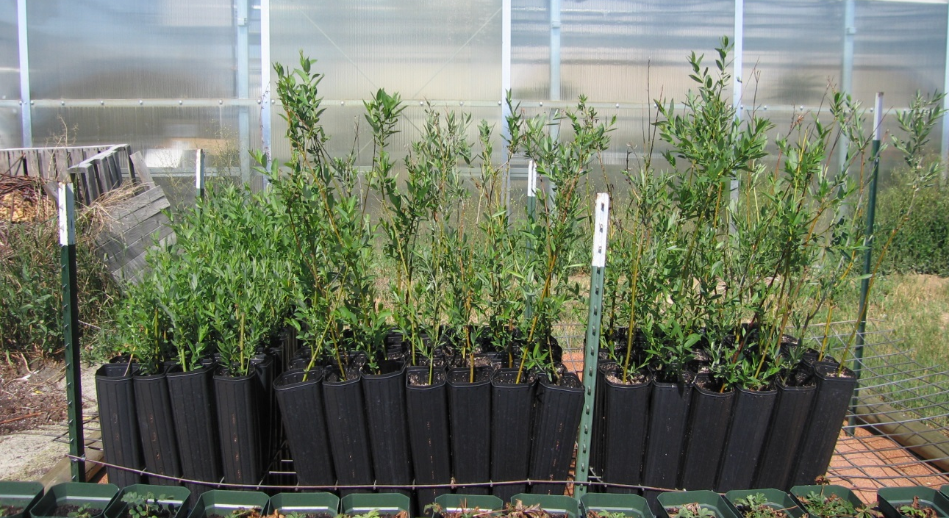
Figure 2. Example of a riparian plant nursery used in a 2007 US Geological Survey restoration project in Walden, CO. These willow starts were hardened-off outdoors in the spring after overwintering and growing inside a greenhouse.

Telluride Foundation Community Grants: Application deadline for grants serving San Miguel, Ouray, and Montrose Counties is October 28, 2013. The Foundation accepts applications for grants $500 and above with requests for the following: general operating support; existing and new programs and projects; non-capital equipment; conferences and seminars; consulting services; matching funds; technical assistance (TA); start-up funds; joint requests from multiple applicants. This could be an opportunity to enhance UWP’s operating funds and/or secure funding for our 2014 OSM/VISTA. An informational webinar for the grant application process is scheduled for Sept. 23, 2013. More information is available at:
http://www.telluridefoundation.org/index.php?page=community-grants

Nonpoint Source Program (NPS) 319 grant: Agnieszka has been collaborating with Jeff Litteral of Colorado DRMS (Division of Reclamation, Mining, and Safety) on revising the Project Implementation Plan (PIP) and budget tables for 2014-2018 mine remediation projects. The grant is comprised of $162,724 NPS funds and $257,084 matching funds. UWP’s grant contract should be finalized in spring 2014 with implementation to start in Apr. 2014.

Water Quality Improvement Fund: As awardee of the 319 grant, UWP automatically qualified for additional $67,884 from the Water Quality Control Division to enhance the mine remediation projects. These funds will be allocated in conjunction with the awarded NPS funds

Table 2. Budget summary as of 9/7/2013.

Funding Source | Allocation | Amount
BOR (CWA sponsor) | UWP expansion | $84,000.00
 | BOR - Invoice 1 | -$1,513.40
 | BOR - Invoice 2 | -$6,045.75
 | BOR - Invoice 3 | -$4,225.49
 | BOR - Invoice 4 | -$5,050.50
 | BOR - Invoice 5 | -$3,377.80
 | BOR - Invoice 6 | -$4,176.50
 | BOR - Invoice 7 | -$3,413.58
 | BOR - Invoice 8 | -$11,944.96
CWCB (Shavano CD sponsor) | CWRP - Riparian Project, Ridgway | $6,000.00
 | CWRP - Invoice 1 | -$4,502.71
 | CWRP - Invoice 2 | -$583.89
 | CWRP - Invoice 3, Closeout | -$913.18
 | CWRP - Balance | -$0.22
 | CHRF - Outreach & Education | $14,000.00
 | CHRF - Invoice 1 | -$3,083.86
 | CHRF - Invoice 2 | -$4,327.31
 | CHRF - Invoice 3 | -$1,113.02
UWP | Balance 9/5/2013 | $5,517.54
TOTAL |  | $55,245.37

Category 3. Assessments, Restoration and Research Projects

Weekly Weed Pulls: This year the regular weed pulls in Rollans Park were not well attended by community members. The staff is considering organizing community weed pulls on a needs basis and and for the annual Pulling for Colorado Event.

Adopt-a-Park Program: On Aug. 23, 2013, Judi, Rhianna and Emily organized the first UWP Volunteer Work Day at Rollans Park which UWP will be stewarding as part of Ridgway’s Adopt-a-Park Program. They were joined by Jerry Roberts, Dudley Case, Jared Coburn, Dave Jones and John Clark. The group sanded every surface of 4 large picnic tables, reset fencing and added mulch to several trees in the vicinity of the park’s parking area. On Sept. 9, 2013, UWP Volunteers will reconvene in Rollans Park to stain the picnic tables; staining has been delayed because of daily rain events.

Category 4. Outreach and Education

Upcoming:
- Coffee with UWP: During September, the UWP Staff, and if possible, Board Members, will be at Backstreet Bistro in Ouray from 9-11am on Wednesdays. Join us to discuss UWP business or send a friend to learn more about the UWP. If you would like to host a one of these events instead of UWP staff, please let us know.

- UWP outings: Grey Copper Trail on September 14th. We will hike the Grey Copper Trail up to the Vernon Mine and back.

- Educational Event with ROCC: Sept. 19, 2013. To celebrate the 49th anniversary of the Wilderness Act, ROCC in partnership with Leave No Trace, the UWFS, Hawk Wilderness Society and the Sheep Mountain Alliance are hosting a wilderness walk for the schools of Ouray, Ridgway, and Telluride Mountain School. The children will go on a 1.5 mile interactive hike, stopping at educational stations along the way. The UWP will host a station with ROCC and teach children about the importance of water for all living things.

- UWP Friends Picnic

- Jon Waterman Presentation: Mark your calendars for December 3 at 7pm at the Wright Opera House for our Jon Waterman fundraiser. Rhianna has been working hard to put this event together, and we hope it’ll generate hundreds of dollars in general funds for future projects and initiatives. If you’d like more information on Jon Waterman, please visit: http://jonathanwaterman.com/

- Fundraiser at The Western: On Sept. 3, 2014, Jerry, Rhianna and Agnieszka met with the owner of the historic Western Hotel in Ouray to brainstorm a fundraiser event for Spring 2014. The planning is in beginning stages but we’re considering a Mardi Gras celebration … start planning your costumes.

- RiverWatch Sampling: Water quality sampling with Ridgway’s 3rd graders will start up again at Rollans Park during the third week of September.

Recently Completed:

- Rollans Park Volunteer Day – Part 1: Judi, Rhianna and Emily organized the first UWP Volunteer Work Day at Rollans Park which UWP will be stewarding as part of Ridgway’s Adopt-a-Park Program. They were joined by Jerry Roberts, Dudley Case, Jared Coburn, Dave Jones and John Clark. The group sanded every surface of 4 large picnic tables, reset fencing and added mulch to several trees in the vicinity of the park’s parking area.

- UWP outings: Silvershield Trail in Ouray, for this hike we were joined by one gentleman from Grand Junction. But, Rhianna received apologies from previous attendees that they were sorry they were going to miss it.

- Ouray County Fair: Aug. 30-31, 2013. This year we hosted a booth at the County Fair, overall attendance at the event hall was low. Though this did give us an opportunity to talk to new people and sell two t-shirts. Susan Long expressed how pleased she was to have us present at the fair and she would like to help us in the future through passing out flyers or possibly with events in the future. She invited UWP to attend the non-profit Holiday Bazaar this year.

- Macroinvertebrate Sampling: Emily and Rhianna met with Ridgway’s biology teacher to discuss macroinvertebrate sampling in October.

