**UWP FINAL LOGO.tifCoordinators’ Report**

**October 12, 2012**

**Prepared by: Agnieszka Przeszlowska**

**& Emily Galanto**

This report reviews tasks included in the 4 strategic categories of the Operating Plan revised Aug. 2012.

Timeline of activities is included at the end of the report (Table 3).

**Category 1. Organization and Coordination**

During the next year Oct. 1, 2012 – Sept. 30, 2013, the UWP will be working toward incorporation to meet the primary objective of watershed group incorporation as required by the recently awarded Bureau of Reclamation (BOR) WaterSMART2012 Cooperative Watershed Management Program. The BOR does not mandate a specific type of corporation. The UWP Steering Committee has agreed to pursue 501(c)3 incorporation. The group has been making progress on developing its bylaws and defining Board structure during the Aug. and Sept. 2012 Steering Committee meetings. Agnieszka and Emily would like to devote most of the next, Nov. 2012 Steering Committee meeting to a bylaws-Board of Directors workshop. We would like to invite a panel of members from local and Colorado non-profits to provide feedback from their experiences and offer suggestions for UWP.

Emily’s OSM/VISTA appointment will be ending in Apr. 2013 and will mark the end of UWP’s sponsorhip cycle (3-y plus 1-y extension). Emily has been an invaluable asset to the UWP and many of the activities we have completed so far would not have been successful without her facilitation. Thus, we are happy to have her for another 6 months. Recruitment of a replacement VISTA will require a new application to the WHWT for a new 3-y cycle which should be submitted in Nov. 2013. This new application will require a work plan that builds on the scope of work of the previous 4-y cycle. WHWT wants to see their members work in new capacities. As UWP transitions from a planning to a project implementation phase the VISTA would be working more with on-the ground projects (i.e. a new capacity). Another way to diversify our next VISTA’s work would be to share their sponsorship with another organization. Agnieszka has been contacted by Sonia Baca, Selenium Task Force (STF), who has requested assistance with their on-going water quality sampling in the lower watershed. Currently, Emily is assisting with this effort which requires about 1 day/month of work. The STF reimburses her for mileage and per diem. The UWP has the opportunity to expand this partnership during the next Apr. 2013-Apr. 2014 VISTA cycle. The STF has offered to help with VISTA sponsorship and requested assistance with water quality sampling as well as other assistance (education, outreach, website, press releases, volunteer events) during UWP’s off-peak season (fall/winter/spring). STF requested 33% of VISTA’s time (1 day/month during summer, 17 h/wk rest of year); 25% time would be 1 day/month, 14 h/wk rest of year. They would provide funds for WHWT sponsorship fees, mileage, per diem and office reimbursements. UWP needs to determine if partnership with STF is appropriate at this time, if yes, what should be the time share?

During Oct. 9-11, Agnieszka and Emily attended the Sustaining Colorado Watersheds Conference in Avon, CO. Their registration was kindly covered by scholarships from the CWCB while travel/lodging expenses will be reimbursed by the BOR grant. The conference was hosted by the Colorado Watershed Assembly, Colorado Riparian Association, and Colorado Foundation for Water Education. Not only did Agnieszka and Emily make numerous contacts with board members from these organizations, but they also networked with staff from San Miguel Watershed Coalition, Coal Creek Watershed Coalition, Lake Fork Conservancy, CDPFHE, EPA, Walsh Environmental, Golder Associates, Colorado River Water Conservation District, CWCB, and others. We attended presentations on river restoration, education and policy, water quality and quantity. We also attended an excellent workshop presented by Eric Eckl of Water Words that Work and gained valuable tools for communication in our community. We will be implementing these strategies on UWP’s website as well as in outreach and education materials. Lastly, during the last day of the conference, Agnieszka attended a Nonpoint Source Program workshop focused on preparation of 319 grants while Emily participated in a field workshop on the Ealge River which comprised of various demonstrations including wetland delineation, groundwater monitoring, soil sampling, riparian plant identification, and channel surveying. This conference was very productive and one not to miss in the future.

**Category 2. Fundraising and Grant Writing**

The CWCB-Water Supply Account did not accept Agnieszka’s and Matt Dare’s, USFS fisheries biologist, proposal for construction of the Crystal Lake fishing pier. The Gunnison Roundtable’s reservation was that the proposed project was purely non-consumptive (i.e. recreational scope) and did not have any consumptive components. Furthermore, the $5,000 Matt Dare had allocated to construction of pier pilings this fall was pulled for the USFS fire program, thus the pilings will likely not be constructed this fall. Agnieszka, Emily and Matt will consider other funding opportunities for the project: GOCO grants, Fishing is Fun program, sources of funding for ADA projects, Ouray Chamber of Commerce, Trout Unlimited, etc.

The Funding Opportunity Announcement for FY2013 Nonpoint Source Program will be released in mid-October. Deadline for applications is Jan. 7, 2013 and CDPHE consultation will end Dec. 14, 2013. Thus, preparation of the grant proposal will be #1 priority for Agnieszka this fall and early winter. She will work closely with Jeff Litteral, DRMS, and Anthony Poponi, Coal Creek Watershed Coalition, on grant writing. We will also consult with the USFS, Ouray Historical Society, Ouray Road and Bridge Dept. as well as local constituents.

As mentioned in the previous Steering Committee meeting, The UWP has applied for $750 from the Ouray Women’s Club to host stakeholder meetings and solicit community input. Every year, the Women’s Club hosts a Rummage Sale, which typically raises several thousand dollars! The organization solicits applications to distribute this money. The grantees will be announced on October 17.

On December 8, 2012, The UWP will be the beneficiary of the Colorado Wine Cheese and Chocolate Fest at the Ouray Community Center. Please mark your calendars! The more in attendance, the more money we will receive. Emily will be assisting with some advertising and other publicity, but please tell your friends to attend!

**Table 1.** Budget summary as of 10/12/2012.

|  |  |  |
| --- | --- | --- |
| **Funding Source** | **Allocation** | **Amount** |
| DRMS (TLR sponsor) | Coordinator | $19,673.07 |
| Coordinator Invoices | -$8,290.00 |
| BOR (CWA sponsor) | UWP expansion | $42,000.00 |
| CWCB (Shavano CD sponsor) | CWRP - Riparian Project, Ridgway | $6,000.00 |
| CWRP - Invoice 1 | -4502.71 |
| CHRF - Outreach & Education | $14,000.00 |
| ROCC - general account |  | $1,065.05 |
| **TOTAL** |  | **$69,945.41** |

**Table 2.** Grants summary, updated 10/12/2012.



**Category 3. Assessments, Restoration and Research Projects**

Phase 2 of the riparian revegetation project in Rollans Park, Ridgway took place on Oct. 6, 2012. Ron Mabry, Agnieszka and Emily were assisted by Rein and Jan Van West, Dudley Case, Dickson Pratt and 4 volunteers from Grand Junction based Humanists Doing Good ([www.humanistsdoinggood.org](http://www.humanistsdoinggood.org)). We spread humates (soila amendement) and native seeds along the eastern stream bank. The area was covered with biodegradable aspen fiber which will remain in place for 12-24 months. Additional seeding on the east side of the river will occur on Oct. 19 & 20. Please join us for this important event. We’ll provide a lunch breakfast and scrumptious lunch, not to mention an opportunity for a great workout … just ask Rein.

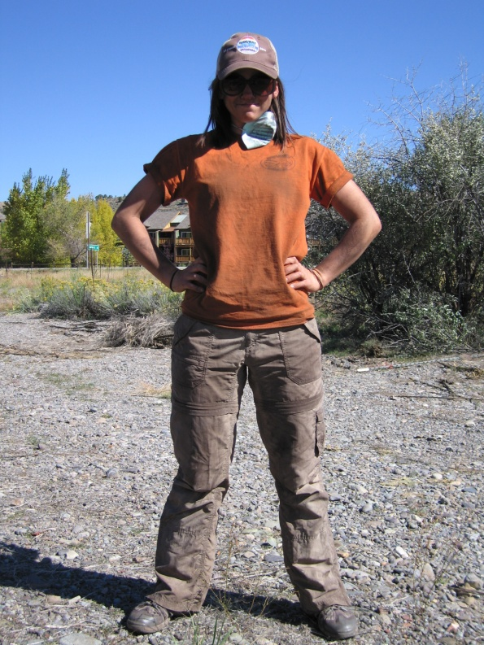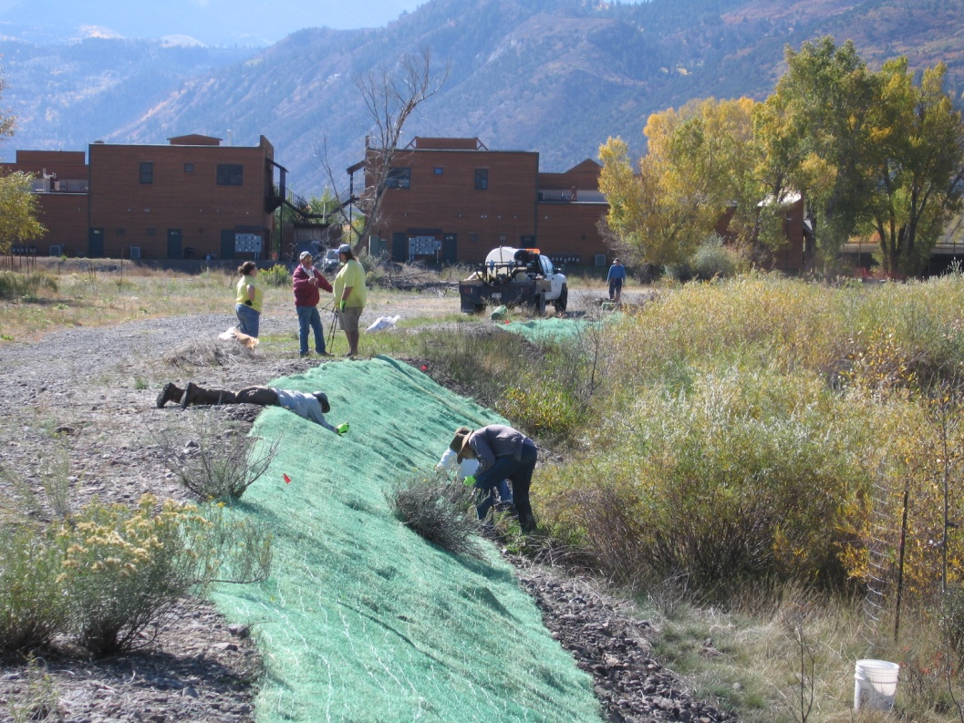**Rollans Park stream bank seeding.**

When it comes to fieldwork, our fearless VISTA is all business … she definitely doesn’t mind getting her hands dirty.

Securing the aspen fiber required some acrobatics. Rein (picture left) got the prize for the best approach

In order to strengthen partnerships with other groups in the Uncompahgre Watershed, Emily will be collecting water samples for the Selenium Task Force every 1-2 months. The sampling effort is funded by the CO River District. There is a Selenium Task Force meeting on October 25 if any Steering Committee members are interested in attending to meet this partnering organization.

**Category 4. Outreach and Education**

**Upcoming:**

* Movie night: Nov. 29, 2012 at the Sherbino Theater: The UWP will be hosting a Movie Night as a stakeholder event and fundraiser! Robert Redford’s “Watershed Movie” is a compelling film concerning issues within the Colorado River Basin. The movie will be shown at the Sherbino Theater in Ridgway at 7pm on November 29. There will be time after the movie for discussion and Q&A. There will also be beer available for extra fundraising! Emily is seeking input on the most effective way to solicit input from the community at the event. One idea is to have suggestion boxes or display boards for community ideas. Please spread the word. Emily will be printing up flyers and other advertising materials and will distribute them at the next SC meeting. Mark your calendars!
* Stakeholder Meetings: we are planning to host several stakeholder meetings this winter and spring. Not only will these meetings fulfill objectives stipulated in the CHRF Outreach and Education grant, but we will also solicit input from stakeholders for future projects. Tentatively, meetings will take place every other month starting in Jan. 2013. Depending on the topic, meetings will be a combination of presentations, roundtable discussions or panels.
* Education Needs Assessment: another project funded by the CHRF Outreach and Education grant is an educational needs assessment for Ouray and Ridgway schools to identify their needs in experiential watershed education. We hope to conduct the assessment by Jan. 2013. We plan to form a committee for each school district to help identify their needs. The committee will comprise of superintendent, School Board representative, teacher from primary and secondary grades, representative from Mount Sneffels Foundation, a couple of local stakeholders/parents, and possibly a member of the Colorado Foundation for Water Education or similar entity.
* Dine out for UWP: On Nov.12, the UWP will be partnering with the Buen Tiempo Restaurant on Main Street in Ouray for a “Dine-out Fundraiser and Trivia Night.” Please mark your calendars! The final details are still pending, so please keep an eye out in your inboxes for more details.
* CO Wine, Chocolate, Cheese Festival: Please purchase, and encourage your friends to purchase, tickets for the Colorado Wine, Chocolate and Cheese Festival on Dec. 8 at the Ouray Community Center. As mentioned in the previous Steering Committee Meeting, the UWP will be the beneficiary of the event – so they more tickets purchased and the more vendors that participate – the more money the UWP will receive!
* Project WET training: On November 9, the Coal Creek Watershed Coalition is offering training on the Project WET Curriculum. Project WET offers dozens of water education activities for youth, and these activities comply with standards for science, math, reading and more. This is perfect for teachers, parents and education oriented groups. If you would like to sign up, please let Agnieszka or Emily know and we will make arrangements.
* Good Samaritan Video: Emily recently contacted Tom Schillaci, Telluride-based 2009 Producer of Environmental Documentary Video for water quality issues at abandoned mine sites, who has recently been awarded a mini-grant from CDPHE to update the Good Samaritan video. He will be interviewing various constituents for this effort and Emily and Agnieszka will be meeting him with on Oct. 16 to provide a UWP perspective.

**Recently Completed:**

* National Public Lands Day: The UWP partnered with Jenny Hart’s 4th grade class at the Ouray Elementary school to celebrate National Public Lands Day on September 28. Thanks to a donation from the World Water Monitoring Challenge Campaign, the UWP acquired a simplistic, kid-friendly water quality testing kit. Emily used this kit to show different parameters of water quality testing and why they are important. It was very successful and will hopefully be repeated every year for NPLD! For photos, you can visit the UWP website, and look under “Past Events.”
* Press Releases: UWP has had a strong presence in the local media, primarily The Watch and Plaindealer newspapers, since spring 2012. We’ve been cited or had press releases in the papers on at least a monthly basis! This has been a great way to raise UWP presence in the community and hopefully entice stakeholders to get involved and consider becoming future Board members.

**Table 3.** Timeline of activities. Priority tasks are highlighted in red.

