**UWP FINAL LOGO.tifCoordinators’ Report**

**August 1, 2012**

**Prepared by: Agnieszka Przeszlowska**

This report reviews tasks included in the 4 categories of the Operating Plan adopted May 10, 2012.

**Category 1. Organization and Coordination**

The next quarterly review of the Strategic and Operating Plans will be during this month’s Steering Committee Meetings. Please review the plans and send any comments to Agnieszka by August 7, 2012 to summarize for meeting.

The Steering Committee discussed incorporation options at the July 16, 2012 meeting but had not made a decision regarding entity structure for UWP. We will continue the discussion at this month’s meeting. Ben Tisdel will follow-up on LLC questions brought up during the July meeting and Scott Williams from ROCC will provide an overview of the 501(c)3 incorporation process.

Registration for the annual Sustaining Colorado Watersheds Conference has opened. Emily and Agnieszka have requested scholarships for registration from the Colorado Water Conservation Board, we will be notified by Aug. 15 regarding the status. The “annual conference works to expand cooperation and collaboration throughout Colorado in natural resource conservation, protection and enhancement by informing participants about new issues and innovative projects and through invaluable networking!” Early registration ends on Sept. 17 and more information can be found at <http://www.coloradowater.org/Conferences>

**Category 2. Fundraising and Grant Writing**

Current budget is summarized in Table 2.

Our next fundraiser will be Community Tap night at Horsefly Brewery in Montrose on August 7, 2012 starting at 6 PM. The brewery will donate a $1.00 for every pint sold. Emily is also organizing a Trivia Contest. This would be a great opportunity not only to sample Horsefly Brewery’s suds but also to network with stakeholders from the lower watershed. If you would like to car-pool we’ll meet in Ridgway at 6PM in the parking adjacent to tennis courts and Hartwell Park (across from Cimarron Booksellers).

Emily is researching funding opportunities with the Walton Foundation and we should have more updates for you soon.

On July 18, Agnieszka and Emily attended a general Steering Committee meeting for Rural Philanthropy Days coming to Western Slope in June 2013. According to OCRA’s Heidi Pankow “For over 21-years, the Community Resource Center (CRC) and the Anschutz Family Foundation have partnered with rural communities throughout Colorado to increase their access to funding, relationships and skill building opportunities through the planning and hosting of Rural Philanthropy Days (RPD). The upcoming Western Slope event involves Front Range grantmakers traveling to your community for three days of activities with rural grant seekers.” Currently, CRC and Anschutz Family Foundation are working with local groups and stakeholders (i.e. Steering Committee) from Delta, Gunnison, Hinsdale, Mesa, Montrose, Ouray and San Miguel Counties to organize the 2013 event. The location will be selected by the Steering Committee and it might be hosted in Ouray – the decision will be made in Sept. After attending the Steering Committee meeting, we decided not to participate in the planning and organization of the event, primarily because it would take away time from UWP work. However, we would like to attend the workshops next summer to seek funding for UWP’s projects.

Agnieszka is preparing a Concept Paper for the upcoming 319 grant cycle. Jeff Litteral will review it before submission on Aug. 10, 2012. Agniesza and/or Jeff will then participate in NPS’s consultation day on Aug. 23, 2012 via teleconference. Based on feedback of the workshop we will then further develop the grant proposal and seek input from the UWP Steering Committee, stakeholders and other partners who should be involved in the project. The primary goal of the project would be to do some mine remediation at 3 possible sites in Poughkeepsie Gulch, Gray Copper Gulch and Canyon Creek.

Agnieszka has been in contact with the USFS Fisheries Biologist, Matt Dare, regarding the proposed Crystal Lake ADA-compliant fishing pier. We will meet again with the BOCC on Aug. 7, 2012 at 10:15 at the Ouray County Courthouse to encourage the Board to reach a decision regarding the proposal. The BOCC is in support of the project but has not acted on a motion to contribute funds and county resources to build pilings for the pier this fall 2012 while the lake is drained for construction work by the Bureau of Reclamation. Pending BOCC’s decision we might have to adjust our grant writing strategy for the Fishing is Fun grant and the CWCB – Water Supply Reserve Account. We’ll have more updates later in August.

A summary of the status of various grants is in Table 1.

**Table 1.** Grants summary.



**Table 2.** Budget summary as of 8/1/2012.

|  |  |  |
| --- | --- | --- |
| **Account** | **Allocation** | **Amount** |
| DRMS - (TLR fiscal sponsor) | Coordinator | 19673.07 |
| PP1: 4/28-6/3/2012 | -1490.00 |
| PP2: 6/4/2012-7/1/2012 | -1600.00 |
|  | PP3: 7/2/2012-7/29/2012 | -1600.00 |
| ***DRMS subtotal*** |  | **14983.07** |
| CWCB | Riparian Project, Ridgway | 6000.00 |
| ***Shavano subtotal*** |  | **6000.00** |
| ROCC - general account | Balance as of 6/14/2012 | 532.28 |
|  | Avalanche Graphics | -4.00 |
|  | Sprout Design Studio | -175.00 |
|  | Silent Auction* | 1050.00 |
|  | FedEx | -36.23 |
| ***ROCC subtotal*** |  | **1367.05** |
| **TOTAL** |  | **$22,350.12** |
| *estimate |  |  |

**Category 3. Assessments, Restoration and Research Projects**

The Uncompahgre River Riparian Health Improvement Project is scheduled for the beginning of August 2012. We have received Notice to Proceed from CWCB and obtained approval from Black Canyon Regional Land Trust, Town of Ridgway, and Ridgway Parks Committee. Phase 1 of the project will include tamarisk removal from 3 locations near and along the Uncompahgre River in Ridgway State Park, totaling approximately 1.5 ac. The work will be primarily done by the Southwest Conservation Corps and Ouray County Weed Manager, Ron Mabry (Aug. 6-8, 2012). Phase 2 of the project will include cottonwood and willow plantings as well as seeding of destabilized stream banks in Rollans Park. Approximately 5 ac of the park will be improved between Aug. 9 -15, 2012. Additional revegetation of the area near the parking lot and the footbridge might take place in Spring or Fall 2013. Timing will be a function of CDOT’s completion of bridge construction and possible construction of foot paths and bike racks near the footbridge. Agnieszka and Emily are working to identify partners to help with costs of bike rack and footpath construction (i.e. Mosaic Community Project, Creative District, Ridgway Area Trails, Western Stream Works).

Emily has been coordinating with Roby Cascade (Ridgway 3rd grade teacher), Barb Horn (River Watch Coordinator) and Arelene Crawford (Ridgway State Park naturalist and River Watch sampler) to add another River Watch monitoring site in Ridgway. The site will likely be located in Rollans Park or vicinity so that the 3rd graders can access it easily from the school.

**Category 4. Outreach and Education**

**Upcoming:**

* Horsefly Brewery Community Tap Night, Montrose – Aug.7, 2012 starting at 6 PM. UWP will lead a Trivia Contest. We’ll car-pool from Ridgway at 6PM, meet in parking lot adjacent to Hartwell Park and tennis courts.
* Emily is coordinating a bird walk along the river corridor with the Audobon Society in August or September. Additionally, she has been in touch with Sheryl Radovich regarding bird banding in Ridgway State Park scheduled for Sept. 15, 2012.
* The BOCC will continue the public hearing concerning tires on the Gunn Property on Aug. 14, 2012 at the Ouray County Courthouse. Agenda and times have not been posted, please check <http://ouraycountyco.gov/BOCC_2012.html> for updates.

**Recently Completed:**

* Lake Appreciation Day took place on July 21, 2012 at Ridgway Reservoir. The UWP hosted a booth where kids were thrilled to simulate non-point source pollution with a watershed model, examine macroinvertebrates collected by Emily and Andrew Madison, and receive fishing demos from Jared Coburn. Free boat tours of the reservoir were offered by the park rangers, Friends of Ridgway State Park hosted a hot-dog and snow-ball stand, and Ridgway State Park generously raffled-off prizes.

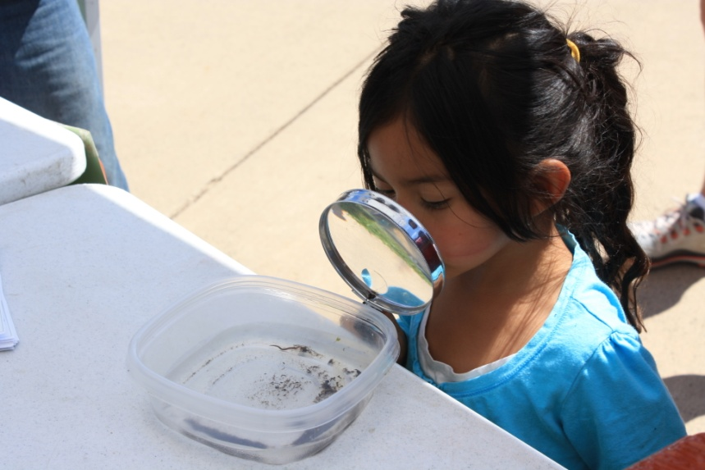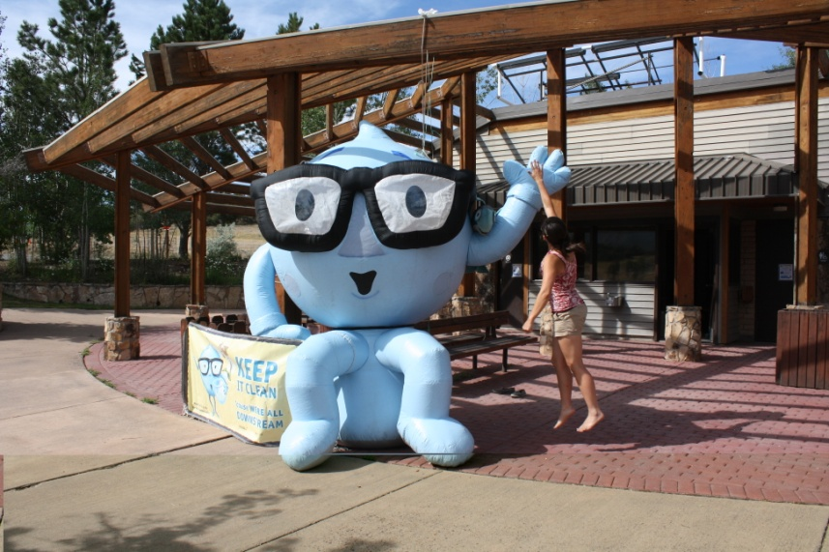

H2O Joe gets a “high-five” from Emily. Future stream ecologist examines stream macroinvertebrates.

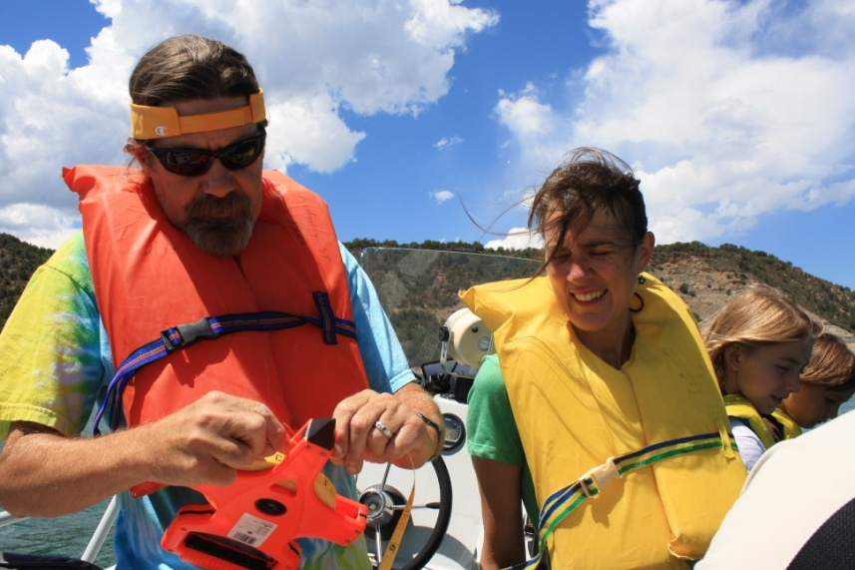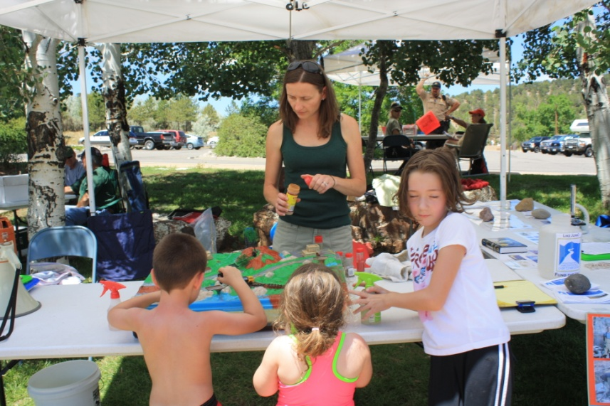

Jeff Litteral, Lynn Padgett and kids on a boat tour of the reservoir during which they measured water clarity (it was 13 ft).

Agnieszka managing the watershed model (at one point our farm became a feed-lot when a youngster “accidently” applied too many chocolate sprinkles).